**Arms race coevolution between bacteria with CRISPR-Cas immune systems and a phage**

Dan Morley1,2, Jack Common1,2, Edze Westra1, Stineke van Houte1*

1ESI and CEC, Biosciences, University of Exeter, Cornwall Campus, Penryn TR10 9EZ, UK

2contributed equally

* correspondence: C.van-Houte@exeter.ac.uk

**Abstract**

**Introduction**

Clustered Regularly Interspaced Short Palindromic Repeats and their associated *cas* genes (CRISPR-Cas) encode an adaptive immune system that is found in approximately 50% of all bacteria and 90% of archaea (ref). CRISPR-Cas confers immunity to phage infection by incorporating phage-derived sequences into CRISPR loci on the host genome. These loci consist of repeating sequences (“repeats”) which are interspaced by sequences (“spacers”) that are derived from phages and other mobile genetic elements of typically around 30nt in length. RNA transcripts of CRISPR loci are processed and form a ribonucleoprotein complex with Cas proteins that can recognise and cleave complementary nucleic acid sequences, preventing future infections by the same phage genotype. CRISPR-Cas systems are highly diverse, and are currently classified into 2 classes, 6 types and 33 subtypes based on their *cas* gene composition, gene synteny and CRISPR repeat sequences, with clear differences in the molecular mechanisms between different variant systems (5).

In some natural environments, bacteria with CRISPR-Cas systems and their phages appear to coevolve over long time periods (Banfield papers; Sundberg). However, studying the dynamics of these coevolutionary interactions under controlled laboratory conditions has been difficult due to the scarcity of available model systems. Specifically, while many bacteria encode CRISPR-Cas immune systems, the vast majority of these bacteria do not evolve CRISPR-based immunity upon phage or plasmid infection, or do so at such low frequencies that they are detectable only with deep-sequencing approaches and unlikely to significantly contribute to the reciprocal selection between the host and the parasite (refs). Currently only two bacterial species have been found to naturally evolve high levels of CRISPR immunity under laboratory conditions, namely *Streptococcus thermophilus* strains DGCC7710and LMD-9 (Barrangou 2008; Horvath 2009), and *Pseudomonas aeruginosa* strain UCBPP-PA14 (Westra Curr Biol).

Early studies with *S. thermophilus* demonstrated that phage can overcome CRISPR immunity through the evolution of point mutations in the sequence targeted by the spacers (the so-called protospacer), or by point mutations in the protospacer-adjacent motif (PAM) (Deveau JBac 2008), a conserved sequence immediately adjacent to the protospacer that is used by the host to discriminate between self (i.e. CRISPR arrays) and non-self (e.g. phage) DNA (Mojica *et al.* 2009; Semenova *et al.* 2011) (Westra PLoS Genet 2013). The observation that phage can evolve to ‘escape’ CRISPR immunity suggested a possible scenario for coevolution in free-running systems, where hosts accumulate spacers over time and phages accumulate escape mutations in the corresponding protospacers or PAMs (refs). Consistent with the idea of CRISPR-phage coevolution, it was reported that *S. thermophilus* and phage can coexist for long periods of time, and that for each treatment the single experimental population increased its bacterial spacer repertoire and the frequency of point mutations in phage genomes over time (ref. Paez-Espino 2x, Sun ISME). However, recent modelling and experiments suggest that the observed coexistence of *S. thermophilus* and its phage may be driven by back mutation of hosts with CRISPR immunity to sensitive phenotypes, which would provide a reservoir for phage amplification and therefore allow their persistence (Weissman ISME 2018). Such loss of CRISPR immunity due to mutation has also been observed at high frequencies in *Staphylococcus epidermidis* (Jiang PLoS Genetics 2013), and may more generally be an important mechanism for bacteria-phage coexistence (Levin PLoS Biol in press). Studies with the *P. aeruginosa* PA14 model system also support the idea that a continuous supply of sensitive hosts is required for bacteria-phage coexistence, and in this empirical system phages were unable to coevolve with CRISPR-immune bacteria due to the high levels of CRISPR spacer diversity that bacteria naturally evolve (van Houte Nature; Chabas ProcB; Westra NRI).

Given the lack of clarity about the role of CRISPR-phage coevolution for bacteria-phage coexistence, we performed highly replicated long-term (30-day) serial transfer experiments with *S. thermophilus* and its lytic phage D2972. Our phenotypic assays demonstrate that bacteria and phages coevolved in these experiments, and that host resistance and phage infectivity increased over time. Furthermore, our genotypic data show that patterns of increased resistance and infectivity were explained by bacteria acquiring novel spacers against the phage, and the phage evolving mutations in the regions targeted by the spacers. Collectively, the data show that bacteria-phage coexistence can be explained by coevolution in this system, and that this coevolution is characterized by an arms-race dynamic.

**EXPERIMENTAL METHODS**

**Strains used in the study**

We used the lactic acid bacterium *Streptococcus thermophilus* DGCC7710 (WT) and its lytic phage D2972 as a model system. DGCC7710has four CRISPR-Cas systems, two of which (CRISPR1 and CRISPR3) are active during infection with phage D2972 and both are classified as Type II-A (Carte et al Mol Micro 2014)(Horvath *et al.* 2008).

**Phage D2972 amplification**

An overnight culture of *S. thermophilus* was transferred 1:10 into fresh LM17 medium (M17 broth supplemented with 0.5% α-Lactose) containing 10mM CaCl2 and incubated shaking at 180 rpm at 42 oC. When the culture reached log phase (OD600 ~ 0.25) approximately 106 plaque forming units (pfus) of phage D2972 were added and the culture was incubated under the same conditions for two hours, at which point cells had fully lysed. Lysates were centrifuged and filtered through a 0.22-µm filter, and the resulting phage stocks were stored at 4 oC.

**Coevolution experiment**

Prior to commencing the experiment, *S. thermophilus* was acclimatised in LM17 medium at 42 oC and 180 rpm for 2 days, with a 1:100 transfer into fresh LM17 after 24 hours. To start the coevolution experiment, bacteria were transferred 1:100 into LM17 media supplemented with 10mM CaCl2 and infected with either 109, 108, 107 or 106 pfus of phage D2972, with 12 independent replicate experiments per treatment, followed by incubation at 42 oC while shaking at 180 rpm. Replicates were transferred 1:100 into fresh LM17 + 10mM CaCl2 every 24 hours and phage titres and bacterial densities were measured every 24 hours for a period of 30 days, or until no phage was detected for four consecutive days. Bacterial densities were determined through plating and colony counts, while phage densities were measured by plaque assays. These were performed by mixing phage dilutions with WT bacteria in soft agar overlays (consisting of LM17 + 10mM CaCl2 and 0.5% agar), poured onto hard agar (LM17 + 10mM CaCl2 and 1.5% agar).

**Measuring evolution of infectivity and resistance**

To measure whether host resistance and phage infectivity evolved during their co-culture, we isolated phage clones and bacterial clones from the treatment where bacteria were infected with 108 pfu phage. For this analysis we used all eight replicate experiments from this treatment where phage persisted for at least nine days. Phage extracted from 1, 4 and 9 days post-infection (dpi) were subjected to plaque assays as described above. For each replicate and time point, twelve plaques were randomly picked and amplified in 96 well plates containing LM17 + 10mM CaCl2 in which WT bacteria were inoculated 1:100 from a fresh overnight culture. Bacteria extracted from the same replicates and time points were diluted and plated overnight, and twelve colonies from each plate were picked at random and used to make lawns on LM17 agar plates supplemented with 10 mM CaCl2. To examine the patterns of phage infectivity evolution, for each of the 8 replicate experiments the 36 phage clones that were isolated (12 phage x 3 time points) were spotted on 36 bacterial lawns corresponding to the bacterial clones from this replicate (i.e. 12 bacterial clones x 3 time points). Phage were classified as being infective against a host if a plaque was visible on the lawn after incubation at 42 oC for 24 hours. If no plaque was visible, the host was classified as resistant. Hence, the infectivity and resistance of phage and bacterial clones was determined for both contemporary interactions (i.e. where the clones had been isolated from the same time point) and with a time shift (where the bacteria and phage clones came from different time points), as shown in Table 1.

**Evolution of infectivity and resistance**

Using the data from the experiments described above, we measured the evolution of phage infectivity as the proportion of bacterial clones that phage from each time point from the same replicate experiment could infect (i.e. how their infectivity range changed over time). In a similar way, we measured the evolution of host resistance as the proportion of all phage genotypes from the same replicate experiment that could be resisted by bacteria from each time point (i.e. how their resistance range changed over time). Infectivity or resistance was analysed in a Generalised Linear Model (GLM) with genotype as a fixed effect and a binomial family with a logit link function. Mean infectivity or resistance was then analysed for each time point in a Generalised Linear Mixed Model (GLMM) using the lme4 package ([Bates](#_ENREF_4" \o "Bates, 2014 #23) *[et al.](#_ENREF_4" \o "Bates, 2014 #23)* [2014](#_ENREF_4" \o "Bates, 2014 #23)), with time point as a fixed effect and replicate as a random effect. Model coefficients and confidence intervals were transformed from logits to probabilities prior to presentation.

**Coevolutionary dynamics**

We further analysed the infectivity and resistance data to infer whether coevolution had taken place, by specifically examining the patterns of resistance and infectivity against phage and bacterial clones from the past, presence and future. Infectivity was measured as the proportion of successful infections, and host resistance as the proportion of unsuccessful infections, corresponding to 1 minus the infectivity value. Infectivity or resistance was analysed in a GLMM with host background (Environment; E) as a fixed effect and the interaction between host background and phage genotype (Genotype X Environment; GxE) as a random effect. Models had a binomial family with a logit link function, with coefficients and confidence intervals transformed to probabilities prior to presentation.

To test for the relative importance of arms race dynamics (ARD) versus fluctuating selection dynamics (FSD) in our experiment, we estimated the strength of the GxE effect on infectivity and resistance following [Hall](#_ENREF_11" \o "Hall, 2011 #15) *[et al.](#_ENREF_11" \o "Hall, 2011 #15)* [(2011)](#_ENREF_11" \o "Hall, 2011 #15). Under a simple arms race, phage should be more infective to hosts from their past compared to their present or future, independent of phage genotype. By contrast, under fluctuating selection phage genotypes will differ in their infectivity to hosts from their past, present or future. Differences among phage genotypes are therefore detectable as the proportion of the host environment (E) residual variance explained by the interaction between host environment and phage genotype (GxE). Increasing values of this proportion relate to increasing differences among phage genotypes. We estimated this by calculating the ratio of the mean square (MS) of an E-only model to the MS of a GxE model for each replicate at each time point. Ratios were then analysed in a GLMM with time point as a fixed effect and replicate as a random effect, with a normal family and identity link function. Residuals were square root transformed to fit the assumption of normality.

**STATISTICAL METHODS**

For all experiments, statistical analyses were carried out in R v3.5.0 (Team 2014), and graphics were generated using r-base and the ggplot2 package (Wickham 2009). Model selection followed a nested design, and the final models in all analyses were selected based on the reduction of heteroskedacity, χ2 tests, and log-likelihood and AIC comparisons (Akaike 1973; Burnham & Anderson 2003, 2004).

**CRISPR sequence analysis**

For all bacterial clones that were isolated from the 8 replicate experiments where bacteria had been infected with 108 pfu of 2972, expansion of the CRISPR1 and CRISPR3 arrays was analysed using PCR to determine whether spacer acquisition had taken place (i.e. twelve clones per time point per replicate = 12 x 3 x 8 = 288 clones in total). Clones that had acquired new spacers were further analysed by Sanger sequencing of the amplicon (Source Bioscience, UK), followed by mapping of the spacers against the phage 2972 genome (Accession: NC 007019.1) using BLAST followed by manual verification using Geneious v9.1.8 (Kearse *et al.* 2012).

**Phage sequence analysis**

**RESULTS**

*S. thermophilus* DGCC7710 encodes four CRISPR-Cas systems, each with a single CRISPR locus (CRISPR1-4). Upon phage 2972 exposure, acquisition of novel spacers has been readily observed in CRISPR1 (the most active locus) and CRISPR3, whereas CRISPR4 and CRISPR2 were shown to be virtually inactive in this context (Paez-Espino Nature Comm, Paez-Espino Mbio; Horvath 2008; Mills et al J Appl Micro 2010). A previous co-culture experiment showed that *S. thermophilus* strain DGCC7710 and its lytic phage D2972 can coexist for approximately 35 days, during which bacteria can acquire novel spacers and phage can acquire point mutations (Paez-Espino MBio). Due to a lack of experimental replication it has remained unclear how representative this observed period of coexistence is and the patterns of bacterial and phage evolution.

We set out to first examine the generality of the previously reported population dynamics following infection of *S. thermophilus* DGCC7710 with a single phage D2972. We therefore infected 12 replicate experimental populations of *S. thermophilus* DGCC7710 with either 106, 107, 108 or 109 plaque forming units (pfu) of phage D2972 (i.e. 48 populations in total), and monitored the bacterial and phage population densities on a daily basis for 30 days. For the first three days following infection, phage titres remained fairly constant in most replicates between 106-108 pfus ml-1, with the exception of the highest phage treatment (109) where phage (and bacteria) went extinct in 11 out of 12 replicates (**Figure 1**). Describe levels of within and between treatment variation here. There was a significant negative relationship between phage titre and host density (*z*= -12.49, DF=594, *p <* 0.0001). While there was a significant interaction effect of initial phage titre on this relationship (*F*(3,591)= 6.07, *p* < 0.001), only the 109 phage treatment had a significantly stronger negative slope compared to the others (*z* = -3.03, DF=591, *p* < 0.01). At 16 days post infection (dpi), the phage had gone extinct in 44 / 48 replicates, and phage persisted for the entire 30-day duration of the experiment in only two replicate experiments. For the treatments where bacteria survived, mean time to phage extinction (days) was for the 109 pfu treatment 2 ± 0.54 days; for the 108 pfu treatment 11.50 ± 1.77 days; 107 pfu treatment 11.50 ± 2.12 days; and 106 pfu treatment 7.67 ± 1.67 days (reported as mean *±* standard error).

Using these experimental lines, we first aimed to determine whether the coexisting bacteria and phages had evolved during their co-culture, with the ultimate aim of determining whether they coevolved. To analyse this, we isolated bacteria and phages from samples taken at 1, 4 and 9 dpi. Specifically, we isolated 12 bacterial clones and 12 phage clones per time point from each replicate experiment where bacteria and phages coexisted for at least nine days. However, since the population dynamics associated with the 106-108 pfus infection regimes was virtually identical, we decided to limit our downstream analyses to the 108 treatment only, resulting in a total of 8 replicate populations that were examined in detail (see **Figure 1**). Using the 288 bacterial clones and 288 phage clones that were isolated from these replicate experiments, we first examined whether the bacteria and phage had evolved increased resistance and infectivity over time. This was done by measuring resistance of each individual bacterial clone against all phage clones derived from the same replicate experiment, and measuring infectivity of each individual phage clone against all bacterial clones from the same replicate experiment. This analysis revealed that mean phage infectivity, i.e. the proportion of all host genotypes that can be infected by a given phage genotype, increased significantly from 0.29 (0.08, 0.48) at 1 dpi to 0.57 (0.37, 0.74) at 4 dpi, but remained stable from 4 to 9 dpi (0.53, [0.33, 0.74]) (reported as mean and 95% confidence intervals [CIs]). Mean host resistance, i.e. the proportion of all phage genotypes resisted by a given host genotype, increased significantly each timepoint, from 0.01 (0.00, 0.05) at 1 dpi to 0.67 (0.18, 0.96) at 4 dpi, and to 0.99 (0.96, 0.99) at 9 dpi (**Figure 2**). Collectively, these data show that bacteria evolved to resist essentially all phage genotypes by 9 dpi, but phage did not evolve high levels of infectivity to match.

Next, we wanted to verify that acquisition of novel spacers formed the mechanistic basis of bacterial resistance evolution during these experiments. We therefore performed PCR analysis on CRISPR1 and CRISPR3 of *S. thermophilus* DGCC7710, since these loci have previously been shown to acquire novel spacers under similar conditions, whereas acquisition of spacers targeting phage D2972 into CRISPR2 and CRISPR4 has not been observed (Horvath 2008; Paez-Espino MBio). This revealed that the mean numbers of spacers per clone increased over time (χ2(6,1140)=32.9, *p*<0.0001)(Figure 3A). Further, all clones acquired at least one spacer by 9 dpi and most had acquired two (0.55 [0.45, 0.65])(Figure 3B). Also correlate with resistance data (**Figure 3**). These data demonstrate that all clones that had acquired resistance also had acquired at least one novel spacer in either CRISPR1 or CRISPR3, suggesting that resistance is CRISPR-mediated. Furthermore, Sanger sequencing of all CRISPR amplicons confirmed that all spacers that had been acquired indeed targeted the phage 2972.

Using these sequencing data, we determined the level of spacer diversity that naturally evolved within each replicate, since this is an important determinant of CRISPR -phage coevolution (Childs PLoS One, van Houte Nature). Indeed, clones in replicates with higher spacer diversity, measured as the pairwise difference (PWD) among spacer sequences, were statistically associated with a lower probability of infection (C=-0.903, z = -9.13, p<0.0001). Consistent with deep sequencing analyses of a previous experimental replicate (Paez-Espino Nature Comm; Paez Espino MBio), our data showed that spacer diversity, in terms of PWD, was generally low (0.25). Despite low overall spacer diversity, there was clear variation among replicates (Figure 3C), and variance among replicates explained 63.90% of the model’s conditional *R*2 (conditional *R*2=0.52, marginal *R*2=0.18). Mean genotype richness was also low, but increasing, across the sampled timepoints (1 dpi = 1, 4 dpi = 1.5, 9 dpi = 2.25)(Supplementary Fig?). The patterns in diversity become especially apparent when the spacers are mapped against the phage genome (**Figure 4**), which shows that the spacer composition between time points can change dramatically, suggestive of selective sweeps.

Wfirst selected56 different phage clones with varying infectivity patterns from the phenotypic assay.We then PCR amplified the identified from the CRISPR spacer sequence data40/56 had acquired at least one single nucleotide polymorphism (SNP) in the protospacer sequence or PAM (**Figure 5A**)**,** the majority (35) of which were located in the target sequence (**Figure 5B)**. Analysis of the infectivity patterns of sequence phage mean probability of infection was significantly higher when phage had a SNP in the protospacer sequence or PAM, compared to phage with no detectable mutations or mutations not associated with the protospacer (χ2(1,766)=48.90, *p*<0.0001)**5C**

Having established that bacteria evolved CRISPR resistance and phage evolved increased infectivity over time in the replicate experiments where they coexisted, we next wanted to examine if they coevolved (i.e. whether bacteria evolve resistance against evolving phage, and vice versa), and if so, what type of dynamics was associated with this coevolution. A phenotypic assay to probe this question are time-shift experiments (refs Hall, Gandon, …), where the susceptibility to infection of bacteria to phage from past, present and future timepoints is measured. Because individual genotypes may differ in their response to time-shift challenges, generalized linear mixed models (GLMMs) with phage genotype as a random effect and phage background (see Table 1) as a fixed effect were used to analyse time-shift data. Models of infectivity showed that hosts were least susceptible to infection from past phage, more susceptible to contemporaneous phage, and most susceptible to phage from their future (Figure 5A) (χ2(4,10044)=5.35, *p*<0.0001).

This pattern of increasing susceptibility from past to future phage generally held true when each pairwise combination of host and phage timepoint was considered (Figure 5B & Table 2). This trend is consistent with an arms race dynamic (ARD), where hosts and pathogens escalate resistance or infectivity over time. However, hosts from 1 dpi were most susceptible to infection from contemporaneous phage. This is more consistent with a fluctuating selection dynamic (FSD), where negative frequency-dependent selection favours rare host and pathogen genotypes. We therefore formally tested for the relative importance of ARD versus FSD in our experiment. Following Hall *et al*. (2011), we estimated the strength of the genotype X environment (GxE) effect on infectivity and resistance Stronger GxE effects are consistent with stronger fluctuating selection (see Methods & Materials). This analysis showed that variation among genotypes, while variable, was also weak, consistent with a limited GxE effect (Supplementary Figure ?). The strength of the GxE effect did not change significantly with respect to timepoint for either phage infectivity (χ2(2,24)=1.93, *p*=0.38) or host resistance (χ2(2,24)=1.46, *p*=0.48). Further, host or phage background in our overall model of time-shift data explained 99.5% of the total variance (Conditional *R*2 = 0.377…, marginal *R*2 = 0.375…), suggesting that genotypes were almost identical in their response to time-shift challenges. Collectively, these data demonstrate that *S. thermophilus* DGCC7710 and phage 2972 coevolved under these experimental conditions, and that the dynamics of their coevolution predominantly follows an arms race.

**DISCUSSION**

*S. thermophilus* DGCC7710 is one of the two best studied models for studying the evolution of CRISPR resistance. Here we present phenotypic data which demonstrate that unlike *P. aeruginosa* PA14 and its phage DMS3vir (van Houte), *S. thermophilus* can coevolve with its phage D2972 under laboratory conditions in an arms race dynamic. This builds on a large body of work showing that *S. thermophilus* readily evolves CRISPR-based resistance in response to phage D2972 through Cas9-dependent spacer acquisition in two active CRISPR loci, CRISPR1 and CRISPR3, which are part of type II-A CRISPR-Cas systems (Barrangou; Horvath; Terns ; Marraffini). Bacteria that carry novel spacers cut the genomes of reinfecting phage within the complementary sequences (protospacers) through the endonucleolytic cleavage activity of crRNA guided Cas9 enzymes (Garneau Nature; Magadan PLoS; Jinek ; Syksnys).

This work presented here is in line with a previous co-culture experiment which also showed that *S. thermophilus* strain DGCC7710 and its lytic phage D2972 can coexist for many generations (Paez-Espino MBio). While the evolution of spacer acquisition in the host and escape mutations in the phage were consistent with coevolution, phenotypic data to support this were lacking. Recently, it was suggested that the observed phage persistence could be driven by back mutation of host resistance to susceptibility (Weissman ISME). While our data do not exclude the possibility that back mutation can play a role in phage persistence, we find strong evidence for coevolution between CRISPR and phage under laboratory conditions, and demonstrate that it is associated with arms race dynamics (ARD), which is characterised by increasing resistance and infectivity ranges over time through the accumulation of spacers in CRISPR loci and point mutations in protospacers. Such ARD-type coevolution may eventually result in phage extinction when bacteria acquire multiple spacers which the phage cannot overcome (Levin PLoS Genet; van Houte), or due to the burden of acquiring increasing numbers of mutations in the phage genome becoming too great for the phage ([Lenski & Levin 1985](#_ENREF_15" \o "Lenski, 1985 #14)). Alternatively, ARD can in some cases give way to fluctuating selection dynamic (FSD) coevolution, which is typified by negative frequency dependent selection, resulting in selection against common bacterial and phage genotypes ([Gómez & Buckling 2011](#_ENREF_10" \o "Gómez, 2011 #16); [Hall](#_ENREF_11" \o "Hall, 2011 #15) *[et al.](#_ENREF_11" \o "Hall, 2011 #15)* [2011](#_ENREF_11" \o "Hall, 2011 #15)). According to our analyses, the contribution of FSD was small during the time period that was sampled here.

In *S. thermophilus*, the acquisition of novel spacers is a rare event (estimated frequency of 1 in … (see Varble et al)), that occurs predominantly in response to defective phages (Hynes & Moineau), or following inactivation of the phage by alternative defense mechanisms (Hynes Nature Comm). This relatively low rate of spacer acquisition compared to *P. aeruginosa* explains why these systems differ with regards to CRISPR-phage coevolution, since high spacer diversity contrains the evolution of escape mutations in the phage (Childs ; van Houte ; Chabas PLoS). Why do CRISPR systems of *Streptococcus thermophilus* and *P. aeruginosa* evolve different levels of spacer diversity? One reason may be the difference in PAM utilization between the two systems. *P. aeruginosa* IF CRISPR-Cas system has a PAM of 2 nt (GG) ([Mojica](#_ENREF_17" \o "Mojica, 2009 #2) *[et al.](#_ENREF_17" \o "Mojica, 2009 #2)* [2009](#_ENREF_17" \o "Mojica, 2009 #2)), whereas the Type II-A system in *Streptococcus thermophilus* has a PAM of 3-5 nt (NGGNG and NNAGAAW) ([Deveau](#_ENREF_9" \o "Deveau, 2008 #12) *[et al.](#_ENREF_9" \o "Deveau, 2008 #12)* [2008](#_ENREF_9" \o "Deveau, 2008 #12); [Horvath](#_ENREF_12" \o "Horvath, 2008 #11) *[et al.](#_ENREF_12" \o "Horvath, 2008 #11)* [2008](#_ENREF_12" \o "Horvath, 2008 #11)), which inevitably causes the latter CRISPR systems to be more restricted with regards to protospacer selection, and consequently have a reduced potential to generate diversity. Another, perhaps more important factor is that the type IF system of *P. aeruginosa* is primed against phage DMS3vir, which triggers rapid spacer acquisition and therefore generation of high spacer diversity at the population level ( van Houte MMBR ; Westra Annual Reviews). Priming relies on the presence of a partial match between a pre-existing spacer and the phage genome, which probably causes low levels of cleavage of the phage genome, hence generating substrates for spacer acquisition (refs priming – especially severinov papers). By contrast, priming has not been described for *S. thermophilus* and the system therefore may rely on naturally inactivated phages, e.g. due to DNA damage, mutation, etc, a relatively rare process (particularly in the lab) which therefore results in lower spacer diversity.

While in primed systems, such as the *P. aeruginosa* Type IF CRISPR-Cas system, the presence of multiple phages may also contribute of bacteria-phage coexistence, another factor that is important in this context is the presence of Anti-CRISPRs in many *Pseudomonas* phages (Bondy-Denomy), which allow phages to amplify if their initial densities are sufficiently high (Landsberger Cell). Such Acr’s have recently also been identified in *S. thermophilus* phages, suggesting they are an important factor in shaping the population dynamics of bacteria with CRISPR systems and their phages, and reflect an additional layer of CRISPR-phage coevolution that takes place over longer time scales.

In natural environments, long-term coexistence between bacteria with CRISPR resistance and their phages has also been observed (Banfield papers), with phenotypic evidence for coevolution (discuss Nature Comm paper Sundberg salmon farm). Such persistent coexistence over many years may be due to a range of ecological and evolutionary factors that are absent from our laboratory environments. For example, previous experiments suggest that longer periods of bacteria-phage coexistence are reached when experimental treatments contained additional phages (Paez Espino 2x). Furthermore, under these conditions, phage were found to escape not only by mutation, but also by recombination (Paez-Espino MBio), an observation consistent with observations from natural environments where phage recombinations were correlated with CRISPR activity (Anderson & Banfield). These examples highlight how biotic and abiotic complexities may be key in shaping the ecological and evolutionary dynamics of host-pathogen interactions, which we are only starting to understand in the context of CRISPR-phage interactions.

**Figure Legends**

**Figure 1: Phage and host population dynamics over time in each replicate**

**A-D)** 109-106 pfu phage treatments, respectively, with replicate identity shown above each sub-panel. Phage titres (plaque-forming units; pfu ml-1) are shown in black and host densities (colony-forming units; cfu ml-1) are shown in blue. The lecel odf detection is 200 pfu/ml, so values of 100 represent undetectable levels of host or phage (i.e. extinction).

**Figure 2: Evolution of infectivity and resistance over time**

**A)** Phage infectivity over time represented as the proportion of host genotypes at all timepoints per replicate that were infected by a sympatric phage genotype. **B)** JHost resistance over time represented as the proportion of phage genotypes at all timepoints per replicate that were resisted by a sympatric host genotype. Means and 95% CIs are shown (*N*=8).

**Figure 3: Spacers acquired during coexistence of *S. thermophilus* and phage 2972**

**A)** Number of acquired spacers per clone at each day post-infection (dpi). Means and 95% CIs are shown (*N*=8). **B)** Mean relative frequency of clones with different numbers of acquired spacers at each dpi. No clone with >3 spacers was detected. Means and 95% CIs are shown (*N=*8). **C)** Spacer diversity in each replicate, measured as the pairwise differences among spacer sequences in each replicate (x-axis) at each timepoint (colours)

**Figure 4: Protospacer locations of newly acquired spacers**

Histogram showing the location of acquired spacers in each replicate when mapped against the 2972 genome: **A)** 1 dpi, replicate 1; **B-E)** 4 dpi, replicates 3, 4, 6 and 7; **F-M)** 9 dpi, all replicates. Each dot represents a clone that had a spacer mapped to that region. Spacers in the CRISPR1 locus are shown in red, CRISPR3 in blue. Darker colours are the result of visual overlap between dots.

**Figure 5:**

**Figure 6: Results from time-shift experiment**

**Figures**

**Figure 1**

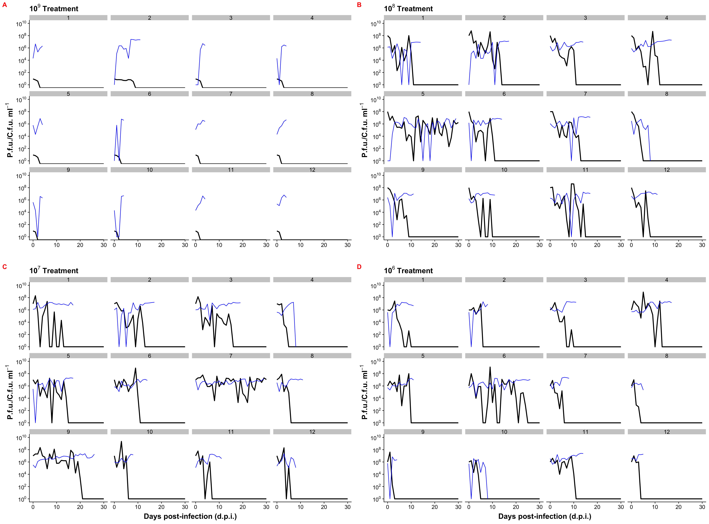

**Figure 2**

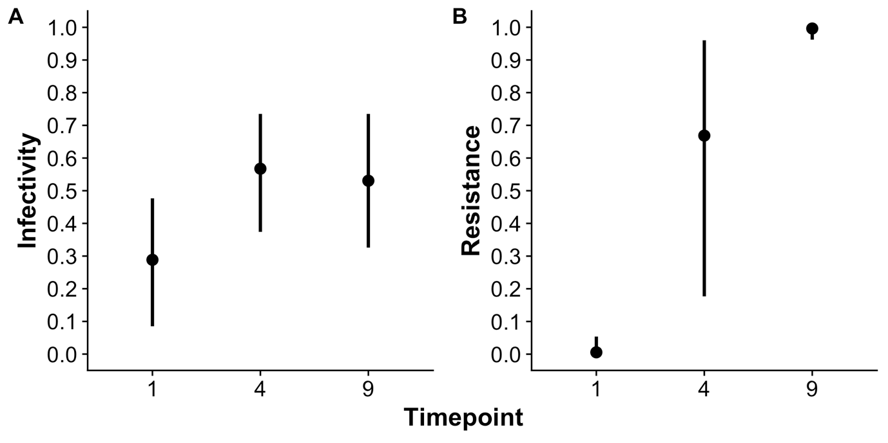

**Figure 3**

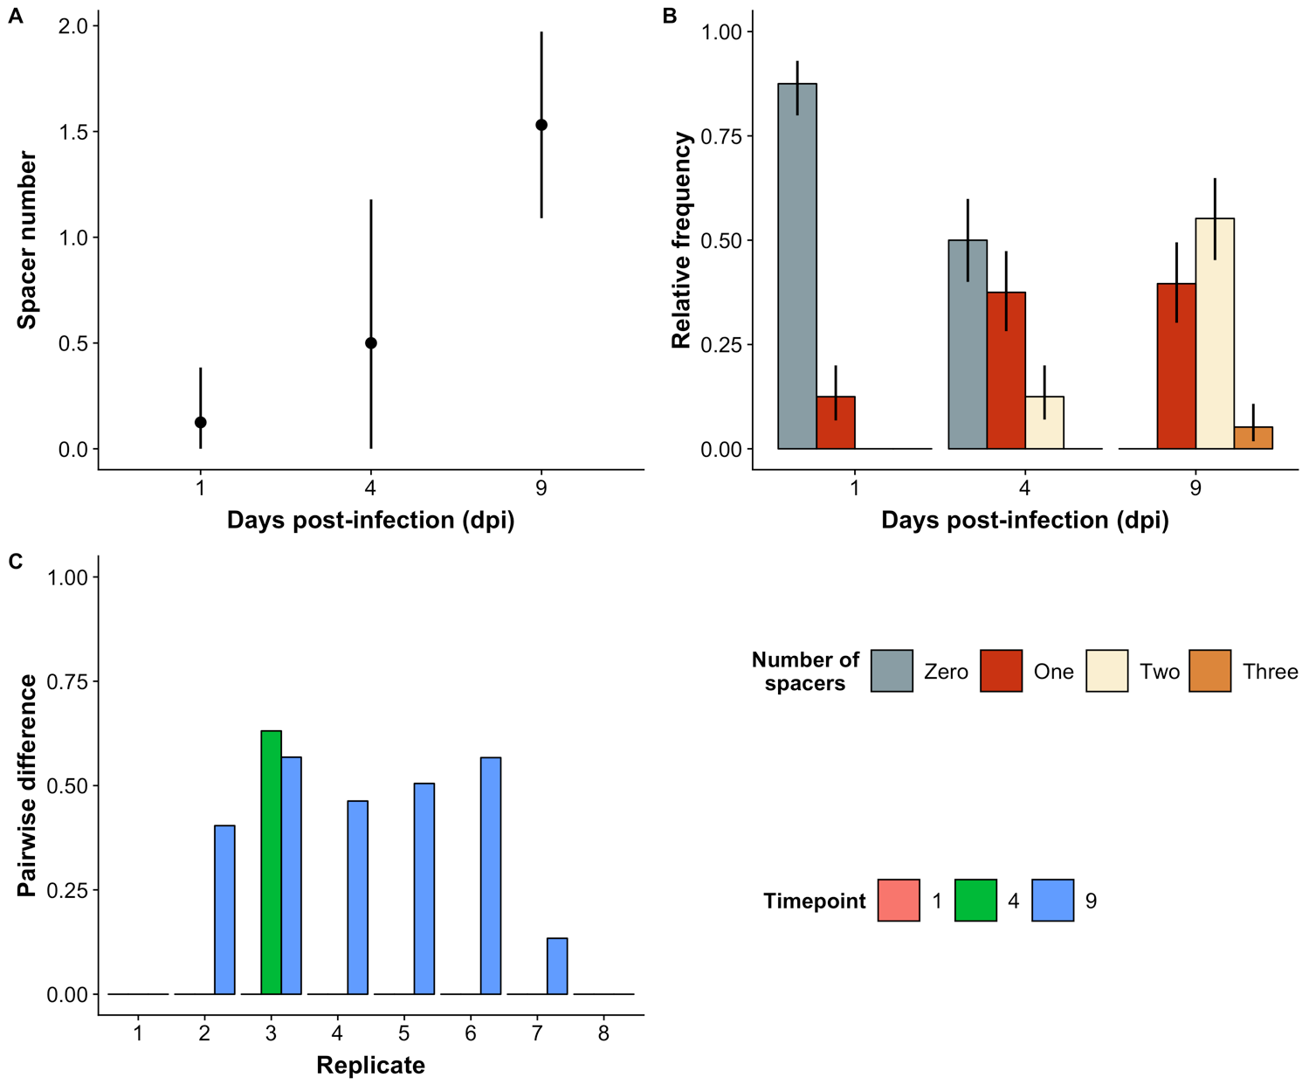

**Figure 4**

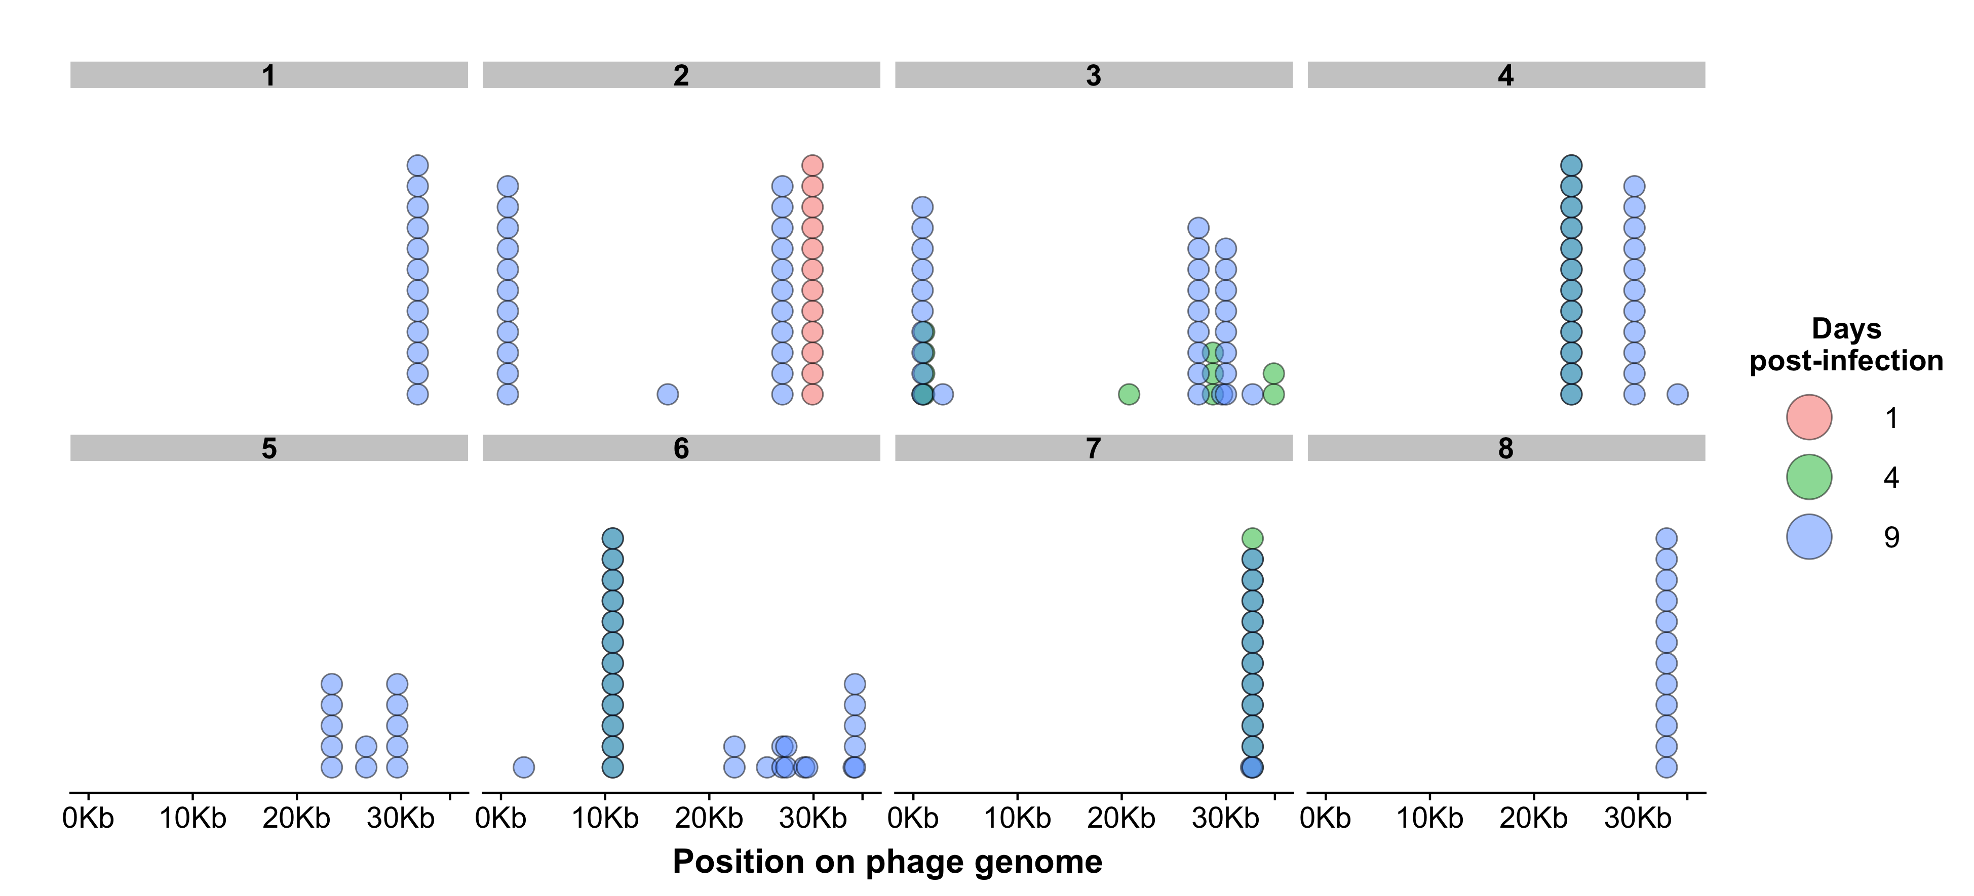

**Figure 5**

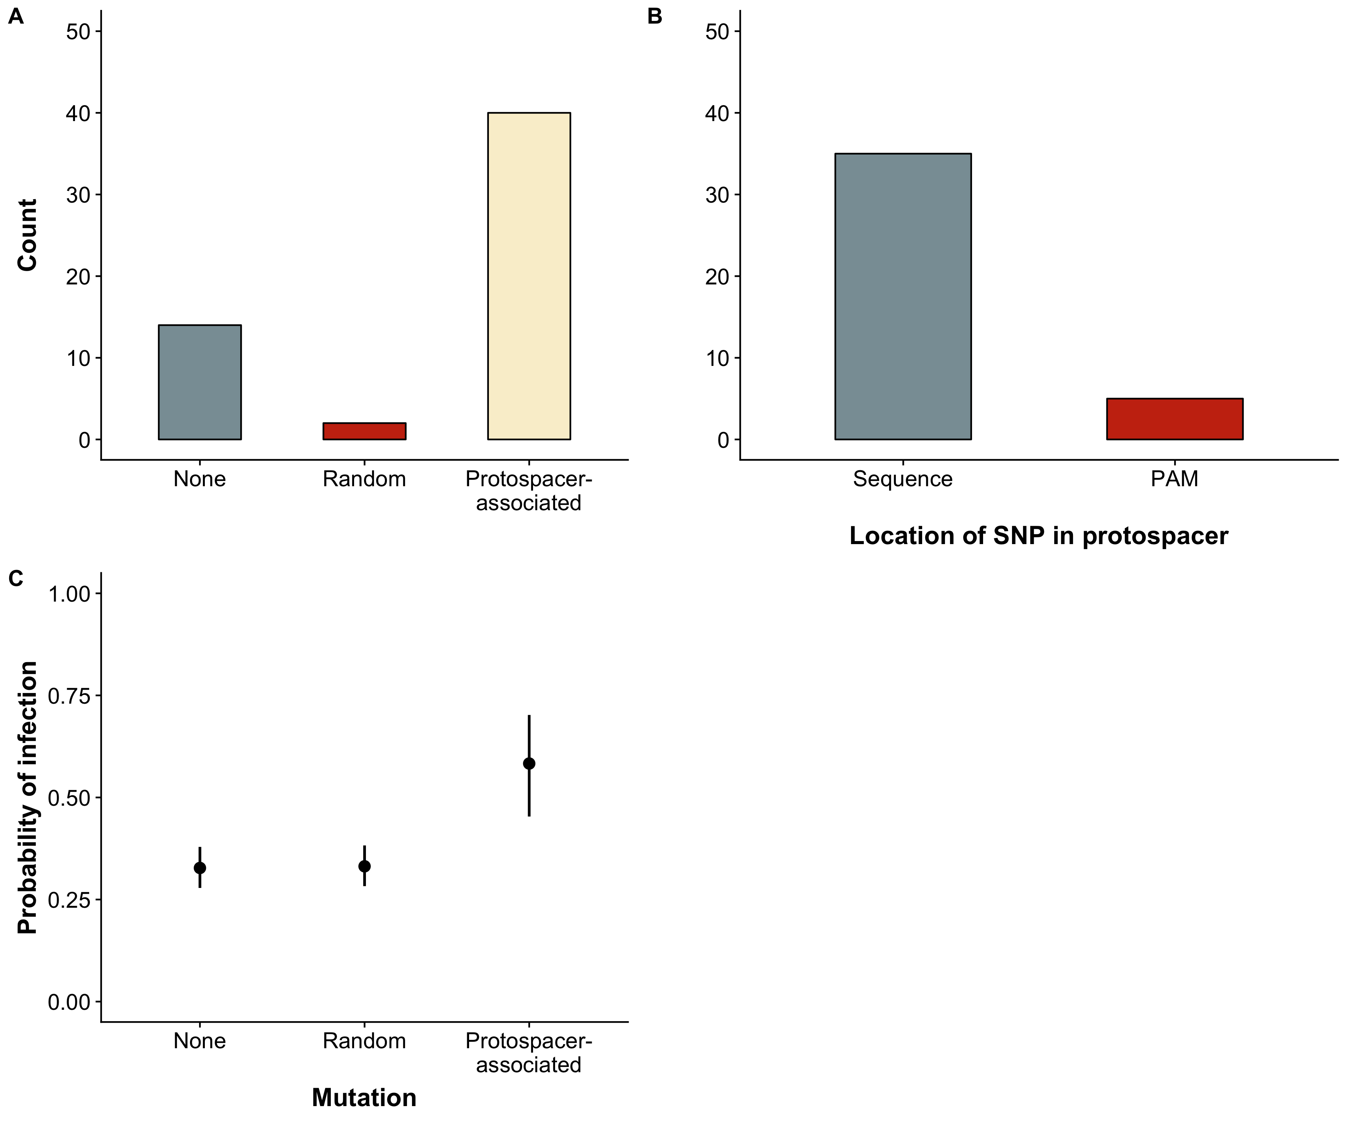

**Figure 6**

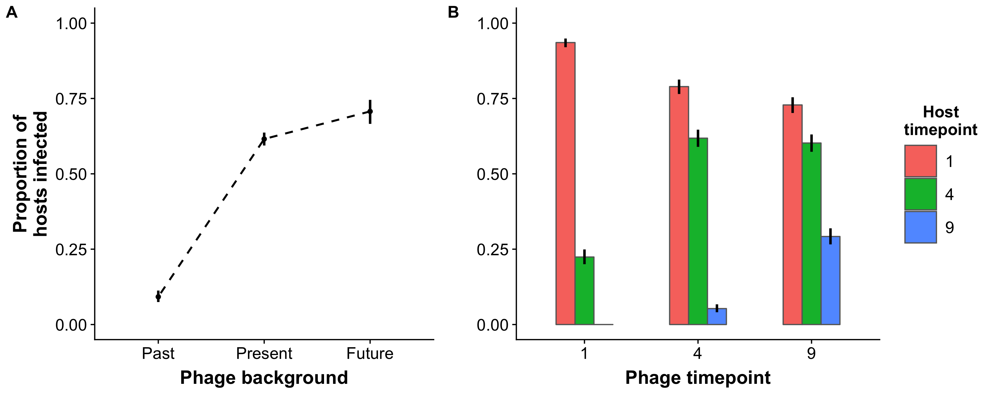

|  |  |  |  |  |
| --- | --- | --- | --- | --- |
|  | | Phage | | |
| **1** | **4** | **9** |
| Host | **1** | Present | Future | Future |
| **4** | Past | Present | Future |
| **9** | Past | Past | Present |

**Table 1:** Pairwise challenges between phage and hosts in the time shift assay. Numbers indicate the time points (days post-infection) analysed. Past, present or future refer to if phage were contemporaneous or not with respect to the host­­.

|  |  |  |  |
| --- | --- | --- | --- |
| **Host origin (day)** | **Phage origin (day)** | **Mean** | **95% CI** |
| 1 | 1 | 0.93 | 0.92---0.95 |
| 4 | 4 | 0.22 | 0.20---0.25 |
| 9 | 9 | 0 | 0.00—0.00 |
| 1 | 1 | 0.79 | 0.76---0.81 |
| 4 | 4 | 0.62 | 0.59---0.65 |
| 9 | 9 | 0.05 | 0.04---0.07 |
| 1 | 1 | 0.73 | 0.70---0.75 |
| 4 | 4 | 0.6 | 0.57---0.63 |
| 9 | 9 | 0.29 | 0.27---0.32 |

**Table 2**: Mean proportion and 95% confidence interval (CI) of hosts infected in pairwise challenges in the time-shift assay, broken down by the day from which the host or phage originated. Values are rounded to two decimal places.

**REFERENCES** (Change to Vancouver style for final copy)

Achigar R, Magadán AH, Tremblay DM, Pianzzola MJ, Moineau S (2017) Phage-host interactions in Streptococcus thermophilus: Genome analysis of phages isolated in Uruguay and ectopic spacer acquisition in CRISPR array. *Scientific reports* **7**, 43438.

Agrawal A, Lively CM (2002) Infection genetics: gene-for-gene versus matching-alleles models and all points in between. *Evolutionary Ecology Research* **4**, 91-107.

Akaike H (1973) Information theory and an extension of the maximum likelihood principle,[w:] proceedings of the 2nd international symposium on information, bn petrow, f. *Czaki, Akademiai Kiado, Budapest*.

Bates D, Mächler M, Bolker B, Walker S (2014) Fitting linear mixed-effects models using lme4. *arXiv preprint arXiv:1406.5823*.

Bhaya D, Davison M, Barrangou R (2011) CRISPR-Cas Systems in Bacteria and Archaea: Versatile Small RNAs for Adaptive Defense and Regulation. *Annual Review of Genetics* **45**, 273-297.

Burnham KP, Anderson DR (2003) *Model selection and multimodel inference: a practical information-theoretic approach* Springer Science & Business Media.

Burnham KP, Anderson DR (2004) Multimodel inference: understanding AIC and BIC in model selection. *Sociological methods & research* **33**, 261-304.

Childs LM, England WE, Young MJ, Weitz JS, Whitaker RJ (2014) CRISPR-induced distributed immunity in microbial populations. *PLoS One* **9**, e101710.

Deveau H, Barrangou R, Garneau JE*, et al.* (2008) Phage response to CRISPR-encoded resistance in Streptococcus thermophilus. *Journal of bacteriology* **190**, 1390-1400.

Gómez P, Buckling A (2011) Bacteria-phage antagonistic coevolution in soil. *Science* **332**, 106-109.

Hall AR, Scanlan PD, Morgan AD, Buckling A (2011) Host–parasite coevolutionary arms races give way to fluctuating selection. *Ecology Letters* **14**, 635-642.

Horvath P, Romero DA, Coûté-Monvoisin A-C*, et al.* (2008) Diversity, activity, and evolution of CRISPR loci in Streptococcus thermophilus. *Journal of bacteriology* **190**, 1401-1412.

Iranzo J, Lobkovsky AE, Wolf YI, Koonin EV (2013) Evolutionary dynamics of archaeal and bacterial adaptive immunity systems, CRISPR-Cas, in an explicit ecological context. *Journal of bacteriology*, JB. 00412-00413.

Kearse M, Moir R, Wilson A*, et al.* (2012) Geneious Basic: an integrated and extendable desktop software platform for the organization and analysis of sequence data. *Bioinformatics* **28**, 1647-1649.

Lenski RE, Levin BR (1985) Constraints on the coevolution of bacteria and virulent phage: a model, some experiments, and predictions for natural communities. *The American Naturalist* **125**, 585-602.

Levin BR, Moineau S, Bushman M, Barrangou R (2013) The population and evolutionary dynamics of phage and bacteria with CRISPR–mediated immunity. *PLoS genetics* **9**, e1003312.

Mojica FJ, Díez-Villaseñor C, García-Martínez J, Almendros C (2009) Short motif sequences determine the targets of the prokaryotic CRISPR defence system. *Microbiology* **155**, 733-740.

Paez-Espino D, Sharon I, Morovic W*, et al.* (2015) CRISPR immunity drives rapid phage genome evolution in Streptococcus thermophilus. *MBio* **6**, e00262-00215.

Semenova E, Jore MM, Datsenko KA*, et al.* (2011) Interference by clustered regularly interspaced short palindromic repeat (CRISPR) RNA is governed by a seed sequence. *Proceedings of the National Academy of Sciences* **108**, 10098-10103.

Team RC (2014) R: A language and environment for statistical computing. R Foundation for Statistical Computing, Vienna, Austria. 2013.

Therneau TM, Lumley T (2015) Package ‘survival’. *R Top Doc* **128**.

van Houte S, Ekroth AK, Broniewski JM*, et al.* (2016) The diversity-generating benefits of a prokaryotic adaptive immune system. *Nature* **532**, 385.

Weissman JL, Holmes R, Barrangou R*, et al.* (2018) Immune loss as a driver of coexistence during host-phage coevolution. *The ISME journal* **12**, 585.

Wickham H (2009) ggplot2: Elegant Graphics for Data Analysis Springer-Verlag New York. Version.